2020-04-15

Assignment 1

CESG 506

Kristinn Hlíðar Grétarsson

Problem 1-1

1.

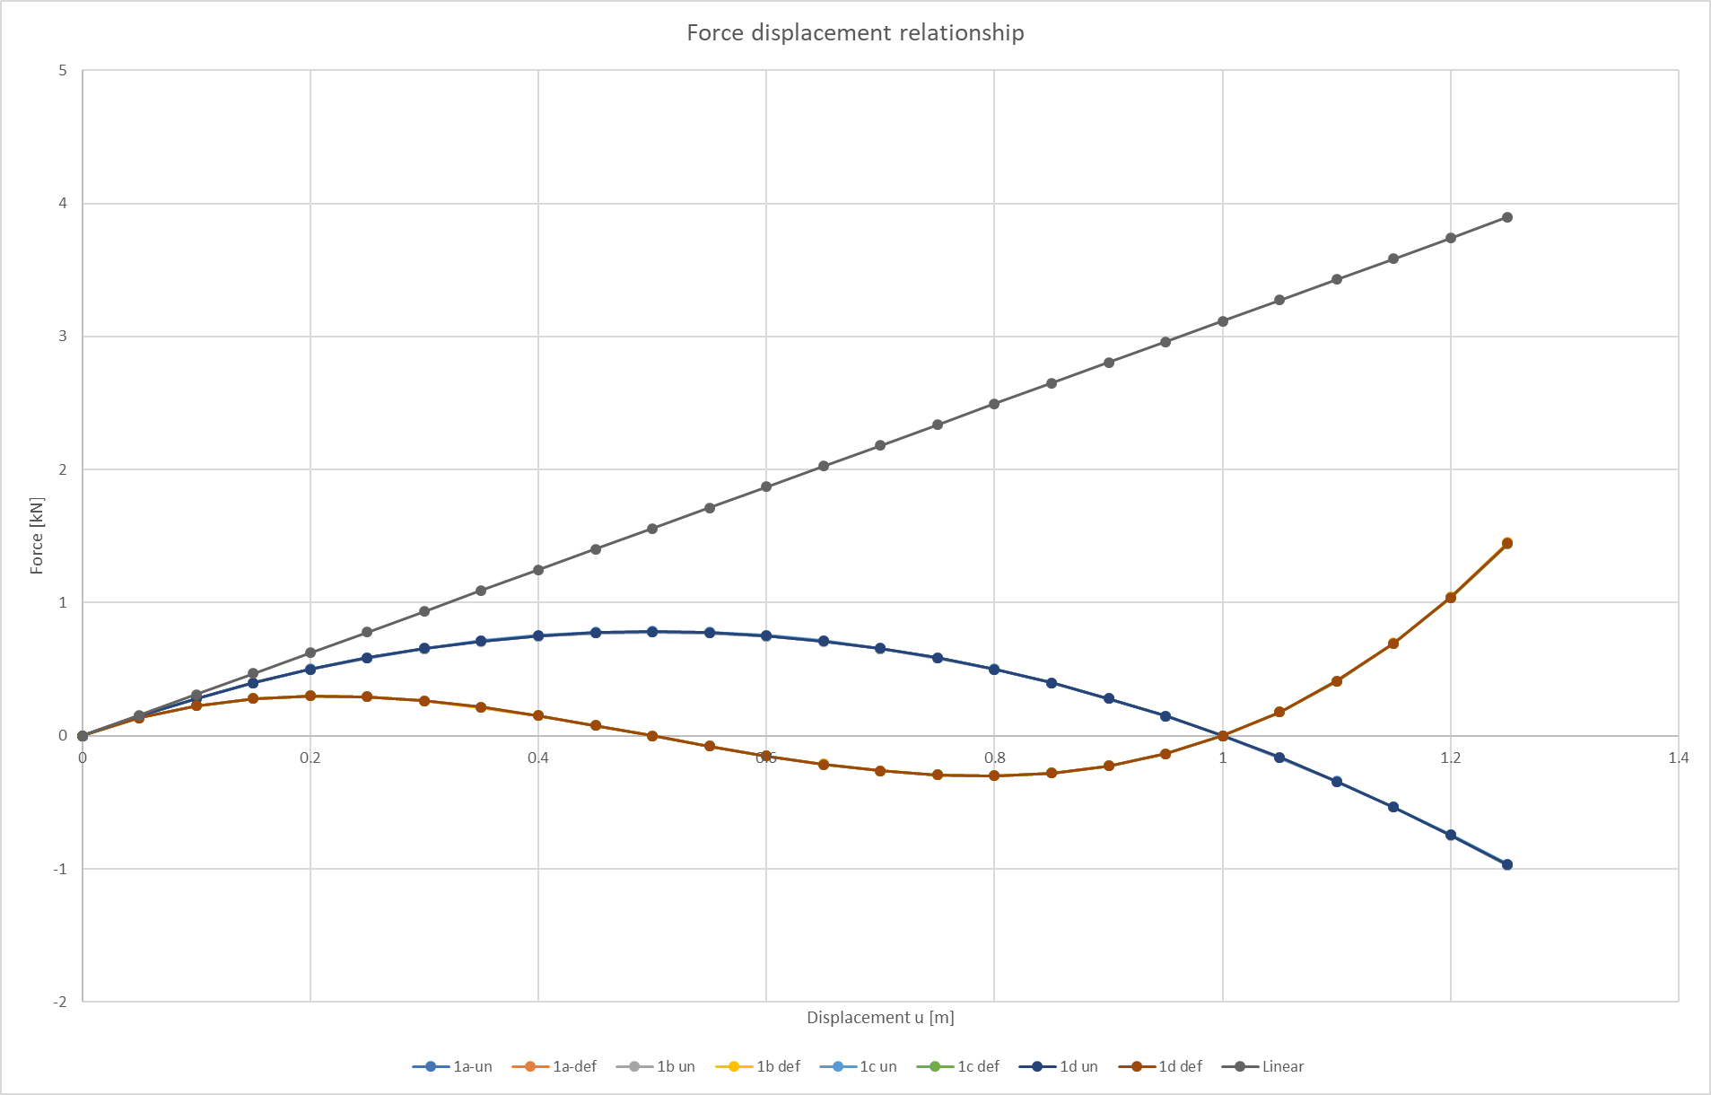

Problem 1-1

2.

What formulation is better would depend on what range I expect to be working in and how accurate the calculations need to be. If I know that I will be working with low loads that will cause small deflections and be in the range where the system is close to linear. I would choose to use linear formulation with the undeformed equilibrium. That makes the calculations much simpler and saves computational power/time.

On the other hand, if I expect the deflections to be large enough for the system to start behaving in considerably non-linear manner. I would choose to use a formulation based on the deformed equilibrium. When it comes to choosing a strain, I wouldn’t worry much about which one I would choose as all of them give really similar results. I would go for strain formulation that would allow for quicker computation.

For larger deformations I would go for a strain that does not blow up to infinity anywhere close to my working range.

Problem 1-2

4.

Pcr was found by controlling vertical displacement and finding the first local maximum as node 2 is moved down wards. Each step of the way horizontal displacement was iterated on to get total horizontal force equal to zero.

Pcr = -0.9817134398668483 kN

Results from each iteration step during the process

Load step = 0

#0 u=0.0000e+00 v=0.0000e+00 Rx=0.000000e+00 Ry=0.000000e+00

Load step = 0.25

#0 u=0.0000e+00 v=0.0000e+00 Rx=0.000000e+00 Ry=2.454284e-01

#1 u=-8.1190e-04 v=-2.4224e-02 Rx=-1.716990e-02 Ry=1.787191e-02

#2 u=-8.5612e-04 v=-2.6212e-02 Rx=-1.135897e-04 Ry=1.188102e-04

#3 u=-8.5642e-04 v=-2.6226e-02 Rx=-5.160655e-09 Ry=5.379573e-09

#4 u=-8.5642e-04 v=-2.6226e-02 Rx=6.616929e-14 Ry=-3.969047e-14

Load step = 0.5

#0 u=-8.5642e-04 v=-2.6226e-02 Rx=6.616929e-14 Ry=2.454284e-01

#1 u=-1.7640e-03 v=-5.4771e-02 Rx=-2.397555e-02 Ry=2.350293e-02

#2 u=-1.8342e-03 v=-5.8018e-02 Rx=-3.059614e-04 Ry=2.969055e-04

#3 u=-1.8352e-03 v=-5.8060e-02 Rx=-5.138651e-08 Ry=4.960239e-08

#4 u=-1.8352e-03 v=-5.8060e-02 Rx=-7.549517e-14 Ry=2.203793e-14

Load step = 0.75

#0 u=-1.8352e-03 v=-5.8060e-02 Rx=-7.549517e-14 Ry=2.454284e-01

#1 u=-2.9006e-03 v=-9.3938e-02 Rx=-3.812335e-02 Ry=3.452191e-02

#2 u=-3.0409e-03 v=-1.0063e-01 Rx=-1.316545e-03 Ry=1.150251e-03

#3 u=-3.0458e-03 v=-1.0087e-01 Rx=-1.674827e-06 Ry=1.446128e-06

#4 u=-3.0458e-03 v=-1.0087e-01 Rx=-3.090861e-12 Ry=2.350675e-12

#5 u=-3.0458e-03 v=-1.0087e-01 Rx=8.482104e-13 Ry=-3.963496e-14

Load step = 0.99

#0 u=-3.0458e-03 v=-1.0087e-01 Rx=8.482104e-13 Ry=2.356112e-01

#1 u=-4.4038e-03 v=-1.5143e-01 Rx=-7.633330e-02 Ry=6.121922e-02

#2 u=-4.9093e-03 v=-1.7656e-01 Rx=-1.886744e-02 Ry=1.366535e-02

#3 u=-5.1060e-03 v=-1.8654e-01 Rx=-2.985580e-03 Ry=2.025239e-03

#4 u=-5.1469e-03 v=-1.8863e-01 Rx=-1.312852e-04 Ry=8.686342e-05

#5 u=-5.1488e-03 v=-1.8873e-01 Rx=-2.884631e-07 Ry=1.899347e-07

#6 u=-5.1488e-03 v=-1.8873e-01 Rx=-1.173284e-12 Ry=8.997247e-13

#7 u=-5.1488e-03 v=-1.8873e-01 Rx=-4.494183e-13 Ry=1.421085e-14

Load step = 0.999

#0 u=-5.1488e-03 v=-1.8873e-01 Rx=-4.494183e-13 Ry=8.835421e-03

#1 u=-5.3659e-03 v=-1.9907e-01 Rx=-3.220339e-03 Ry=2.080566e-03

#2 u=-5.4500e-03 v=-2.0338e-01 Rx=-5.605904e-04 Ry=3.537781e-04

#3 u=-5.4716e-03 v=-2.0449e-01 Rx=-3.705937e-05 Ry=2.311145e-05

#4 u=-5.4732e-03 v=-2.0457e-01 Rx=-2.090722e-07 Ry=1.300174e-07

#5 u=-5.4732e-03 v=-2.0457e-01 Rx=-6.854961e-12 Ry=4.194978e-12

#6 u=-5.4732e-03 v=-2.0457e-01 Rx=8.526513e-13 Ry=1.676437e-14

1-2

5.

I could compute to 1x10-13 kN error. As soon as I went to 1x10-14 kN my code did not converge which was a cut of point for all the load steps.

|  |  |  |
| --- | --- | --- |
| Load step = 0  0, 0.000000e+00  Load step = 0.25  0, 2.454284e-01  1, 2.478327e-02  2, 1.643730e-04  3, 7.454674e-09  4, 7.716028e-14  Load step = 0.5  0, 2.454284e-01  1, 3.357401e-02  2, 4.263394e-04  3, 7.142108e-08  4, 7.864598e-14 | Load step = 0.75  0, 2.454284e-01  1, 5.143104e-02  2, 1.748247e-03  3, 2.212765e-06  4, 3.883181e-12  5, 8.491359e-13  Load step = 0.99  0, 2.356112e-01  1, 9.784971e-02  2, 2.329640e-02  3, 3.607670e-03  4, 1.574200e-04  5, 3.453783e-07  6, 1.478546e-12  7, 4.496429e-13 | Load step = 0.999  0, 8.835421e-03  1, 3.833972e-03  2, 6.628880e-04  3, 4.367535e-05  4, 2.462026e-07  5, 8.036686e-12  6, 8.528161e-13 |

